Why do we do what we do?
What exactly are we doing?

Asking Good Questions

Name of Author

XX/XX/XXXX

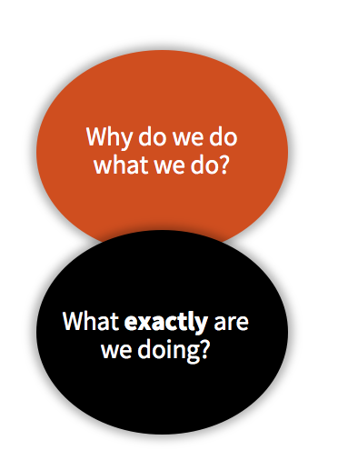
Questions 1 and 2 are about understanding context, and designing a high-quality ‘offer’ that responds to this context. These questions are really important in laying the foundation for both delivery and evaluation. It’s very hard to evaluate your work without answering these two questions really well.
In other words – we have to clearly describe what we’re seeking to do, how and why we’re doing it in that way, if we want to be able to understand the quality of our work, whether it’s making a difference, and why.

  - How are you applying this framework to your work? This framework could be applied to your whole organisation’s practice, or a specific programme/project.

Question 1: Why do you do what you do?
  - Context
What do you know about the assets, needs, and interests of the young people you work with or intend to work with? What information do you have?

  - What else do you want or need to know about the context you are working within, and how could you go about finding out?

  - Approach
  - How would you describe your approach to working with young people?

  - Why has your organisation chosen this approach? Are there other approaches you could have taken?

Question 2: What exactly do you do?
  - Can you identify the following components of a theory of change for the area of work you are applying this framework to?
  - Aim

  - Outcomes

  - Mechanisms of Change

  - Activities

  - Which elements of your provision are ‘core’ and ‘flex’?
Core

Flex

  - What do you know about ‘dosage’ - duration and intensity – for the young people you work with, and how it affects the impact of your provision?

