Are we doing it consistently well?
Are we staying true to our intentions?

Asking Good Questions

Name of Author

XX/XX/XXXX

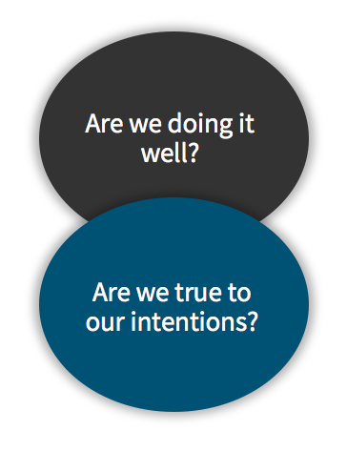
Questions 3 and 4 are about carefully monitoring the delivery of activities, to understand whether high-quality work is being delivered consistently and with fidelity to your design and ‘intentions’. This includes understanding whether young people are engaging in the way you hoped or expected.

Question 3: Are you doing it consistently well?
  - How does your organisation define quality in its work?

  - How does your organisation monitor and improve quality? What more could be implemented to support improvement?

Question 4: Are you staying true to your intentions?
  - What are the key sources of monitoring data that your organisation routinely collects, and why? How do they relate to your intentions?

  - Based on this information, what conclusions can you draw about whether your provision is staying true to its intentions and why?

  - What other types of potentially useful data are missing?

